# How to invoke Javascript (JS) at Native, and invoke native at JS in WebView of Universal Windows Platform (UWP)

## Introduction

Hybrid is a popular shape of modern apps, and many people asked about how to invoke JS at Native, and invoke Native in WebView.

This sample will demonstrate about this topic.

## Sample prerequisites

To open and run the sample, ensure the following requisites has been reached:

* Microsoft Windows 10(10.0.14393) or above.
* Microsoft Visual Studio 2015 Update3 or later version(s).
* Microsoft Visual Studio installed UWP developer component.

## Building the sample

* Open the sample solution “**CSCommunicationBetweenJsAndNativeCodeInWebViewOfUWP**” using Visual Studio.
* In Solution Explorer, right click project “**CSCommunicationBetweenJsAndNativeCodeInWebViewOfUWP**” and select Set as StartUp Project.

## Running the sample

* Use Visual Studio to open the sample solution, then press **F5 Key** or select **Debug -> Start Debugging** from the menu.
* When the app is running, you can see this:

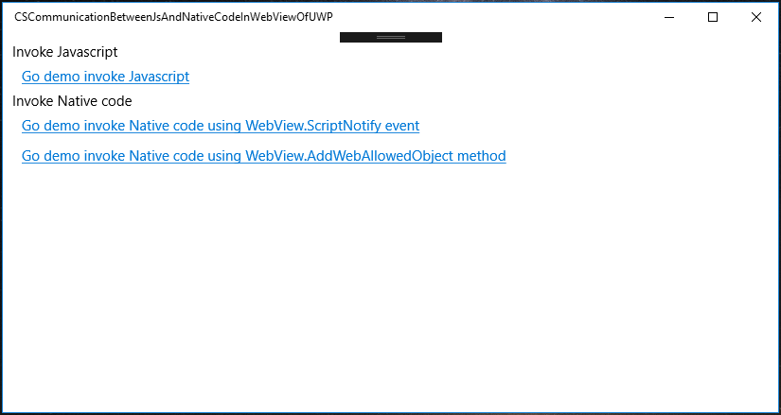

**Invoke Javascript**

* Click Link “**Go demo invoke Javascript**” go to the **Invoke javascript function from UWP** page.

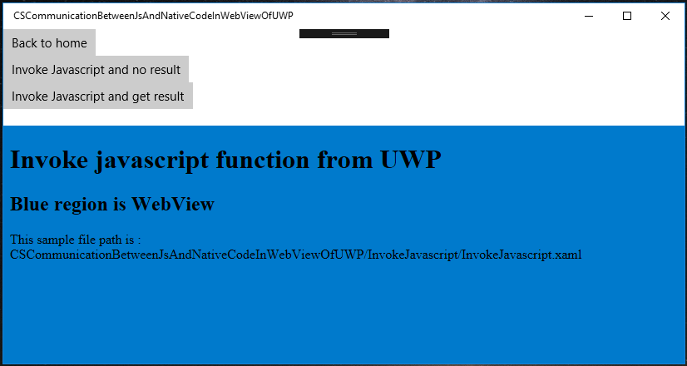

* Click button **Invoke Javascript and no result**. The app will invoke javascript function, and JS will change the html content.

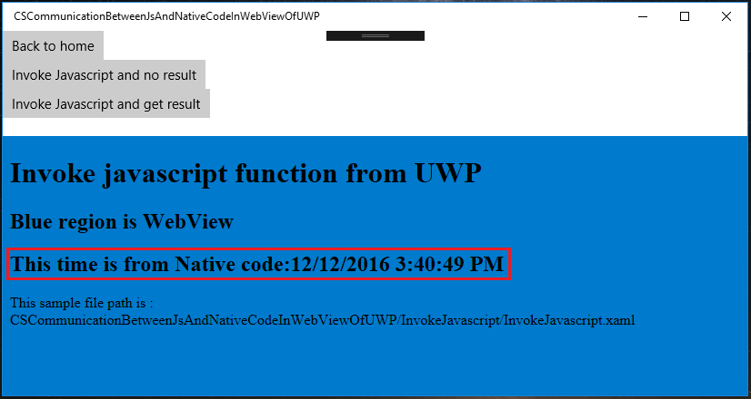

* Click button **Invoke Javascript and get result**. The app will invoke javascript function, and get result to the app UI.

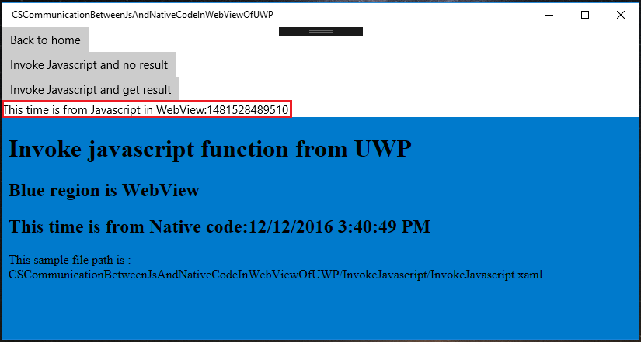

* Click button **Back to home** back go to home.



**Invoke Native code**

* Click link **Go demo invoke Native code using WebView.ScriptNotify event**.

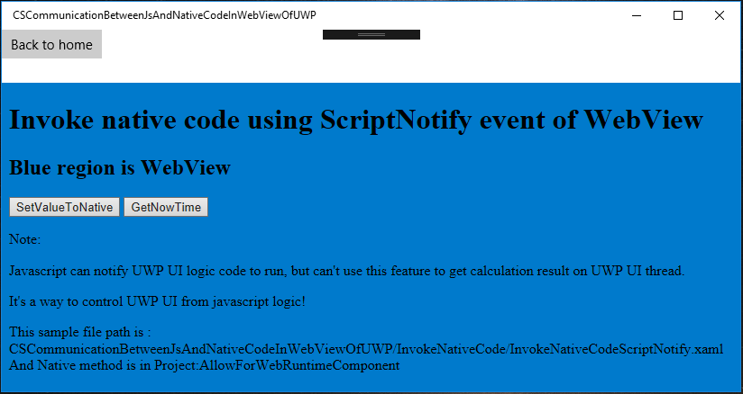

* Click button **SetValueToNative**, JS will call the Native code with the parameter “**this value is from webView.**”, and Native code will change the UI by the parameter.

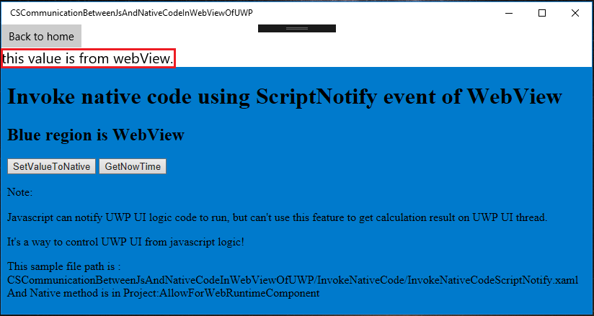

* Click button **GetNowTime**, JS will call the Native code with no parameter, and Native code will generate a Date.Now data and print to UI.

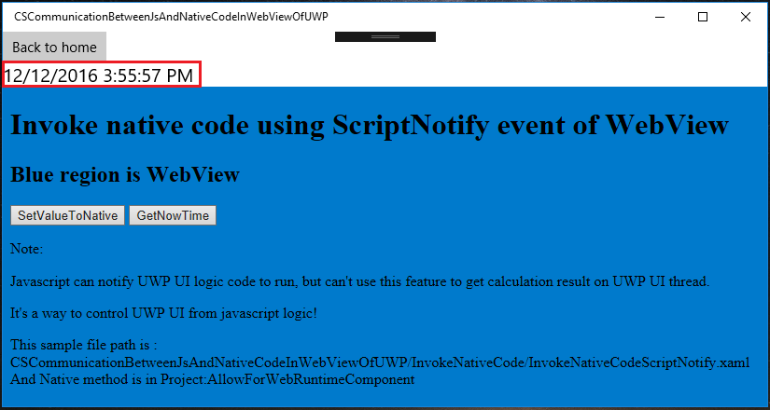

* Click button **Back to home** back go to home.



* Click **Go demo invoke Native code using WebView.AddWebAllowedObject method**.

The JS will call the Native code and get the result to the html.

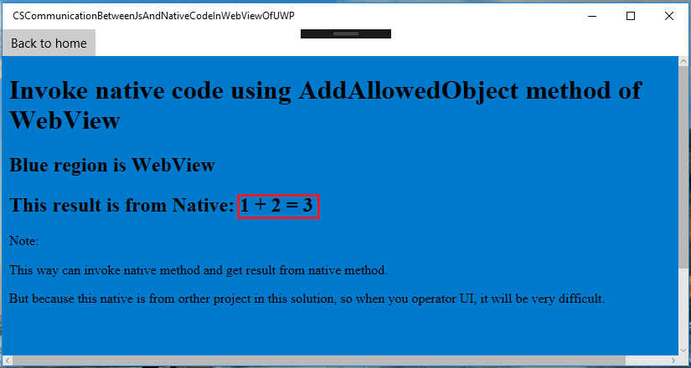

## Using the code

**Invoke Javascript:**

JS:

function invokeJSAndNoResult(param) {

var invokeJSAndNoResultContainer = document.getElementById("invokeJSAndNoResultContainer");

if (invokeJSAndNoResultContainer) {

invokeJSAndNoResultContainer.innerHTML = param;

}

}

XAML:

<WebView Grid.Row="2" Name="MainWebView" Source="ms-appx-web:///InvokeJavascript/InvokeJavascript.html" />

C#:

private async void RunJsAndNoResultBtn_Click(object sender, RoutedEventArgs e)

{

string nowStr = string.Format("This time is from Native code:{0}", DateTime.Now.ToString());

try

{

//the first param is the function name of javescript,

//the second is the parameter of function

await MainWebView.InvokeScriptAsync("invokeJSAndNoResult", new string[] { nowStr });

}

catch (Exception ex)

{

MessageDialog showDialog = new MessageDialog(ex.Message);

await showDialog.ShowAsync();

}

}

**Invoke native code using ScriptNotify**:

XAML:

<WebView Grid.Row="2" Name="MainWebView" ScriptNotify="MainWebView_ScriptNotify" Source="ms-appx-web:///InvokeNativeCode/InvokeNativeCodeScriptNotify.html" />

C#:

private void MainWebView_ScriptNotify(object sender, NotifyEventArgs e)

{

//the notify value just a string,you can provide a format json,xml,or just a string

//in this sample I provide a string that is a json format,and I use it to simulation method route

JObject jo = JObject.Parse(e.Value);

string method = jo.SelectToken("method").Value<string>();

switch (method)

{

case "GetNowTime":

GetNowTime();

break;

case "SetValueToNative":

string param = jo.SelectToken("param").Value<string>();

SetValueToNative(param);

break;

}

}

JS:

window.external.notify(JSON.stringify({ method: "SetValueToNative", param: "this value is from webView." }));

**Invoke native code using WebAllowedObject**:

At Windows Runtime Component(Universal Windows) project "**AllowForWebRuntimeComponent**".

[AllowForWeb]

public sealed class AllowFromWebExample

{

public int GetPlusResult(int param1, int param2)

{

return param1 + param2;

}

}

XAML:

<WebView Grid.Row="1" Name="MainWebView" NavigationStarting="MainWebView_NavigationStarting" Source="ms-appx-web:///InvokeNativeCode/InvokeNativeCodeAddWebAllowedObject.html" />

C#:

private void MainWebView_NavigationStarting(WebView sender, WebViewNavigationStartingEventArgs args)

{

//This way can invoke native method and get result from native method.

//But because this native is from orther project in this solution, so when you operator UI, it will be very difficult.

sender.AddWebAllowedObject("AllowFromWebExample", new AllowForWebRuntimeComponent.AllowFromWebExample());

}

JS:

var result = AllowFromWebExample.getPlusResult(1, 2);

## More information

Web view introduction:

<https://msdn.microsoft.com/en-us/windows/uwp/controls-and-patterns/web-view>